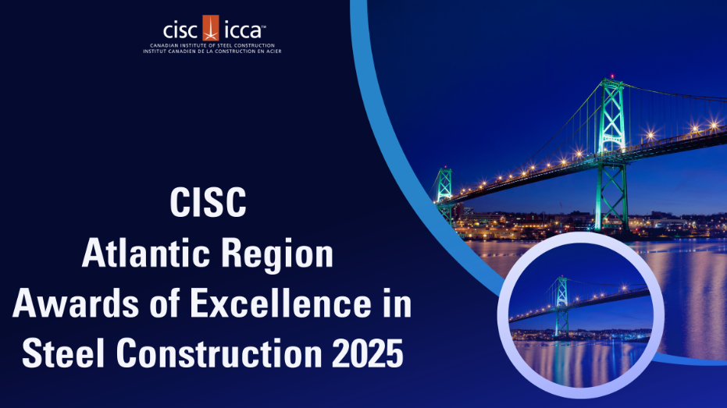

The CISC Atlantic Region Awards of Excellence in Steel Construction is the most prestigious steel event of the year in Atlantic Canada highlighting exceptional design, teams and projects that demonstrate the versatility, durability and limitless solutions when using steel.

Project Submission Criteria and Eligibility Requirements

- CISC Atlantic Bridge Award
- CISC Atlantic Engineering Award
- CISC Atlantic Architectural Award
- CISC Atlantic Sustainability & Innovation Award
- CISC Atlantic Cold Formed Steel Award
CISC Atlantic Steel Bridge Award
Highlighting bridge projects which demonstrate outstanding use of steel in design and construction of the bridge.
CISC Atlantic Engineering Award
Highlighting steel structures in which engineering considerations and the efficient use of steel in unique applications are the predominant factor. All building types and bridges.
CISC Atlantic Architectural Award
Highlighting steel buildings or structures in which architectural considerations predominantly influence the design, particularly those with exposed steelwork. All building types and bridges.

CISC Atlantic Sustainability & Innovation Award
Highlighting and rewarding a company that has provided exceptional leadership in advancing the steel construction industry through innovative design or innovative new products, investments in technology, the improvement of sustainability of steel structures, or safety.

CISC Atlantic Cold Formed Steel Award

Highlighting projects where the selection of cold formed steel was chosen to solve engineering, architectural or constructability challenges. Consideration will be given to engineering and architectural ingenuity, creativity, and innovation.

Eligibility criteria for project submissions
- Projects located in Atlantic Canada
  - Steel Fabricator/Manufacturer must be a CISC member, and
  - At least 1 (one) project company team member shall be from the following categories and located in Atlantic Canada:
    - Steel Fabricator/Manufacturer
    - Consulting Engineer
    - Steel Erector
    - Steel Detailer, or
    - Architect

- Projects located outside of Atlantic Canada are eligible for submission provided the Steel Fabricator for the project is a CISC Atlantic Region Member.
- Eligibility for the Sustainability & Innovation Award is available only to CISC Atlantic Members, CISC Atlantic Associates, and Atlantic based engineers and architects.
- All submitted projects must be substantially completed (steel framing) between the time period of January 01, 2020 – June 1, 2025.

How to submit a project:
Submit a project on the following link https://www.judgify.me/2024CISCATL by registering and submitting the online registration form with all the mandatory information by the deadline of June 01, 2025 (midnight Atlantic time)**.
**Please note, project submissions will not be accepted after this date.

